Troubleshooting Common Issues

Common Issues and Solutions
- Column Wasn’t Found
  - Issue: The Power BI template is expecting a metric within the CSV file that was not found. For example, it is missing metrics such as "Copilot chat (work) prompts submitted."
  - Solution: Identify the metric name displayed in the screenshot and re-execute your query including the missing metric.
  - Steps:
    - Open your Viva Insights CSV file.
    - Ensure all suggested metrics in GitHub are included in your query and add any missing metrics as needed.
    - Re-run your Viva Insights query including all necessary metrics.
  - Screenshots:
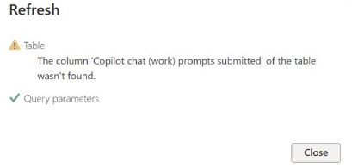
- Locale Issues
  - Issue: The Power BI template recognizes US date format "MM/DD/YYYY." If using "DD/MM/YYYY," you may have occasionally run into issues with specific visuals. To fix this, follow the steps below to change the template from English (US) to English (EU).
  - Solution:
    - Open Power BI Desktop, click on the "File" menu in the top-left corner.
    - Select "Options and settings" from the dropdown menu and click "Options."
    - In the Options window, go to the "Regional Settings" section.
    - Under "Locale for import," select the desired locale from the dropdown menu and click "OK" to apply the changes.
This will change the locale settings for data import, which can affect date, time, and number formats in your Power BI reports.
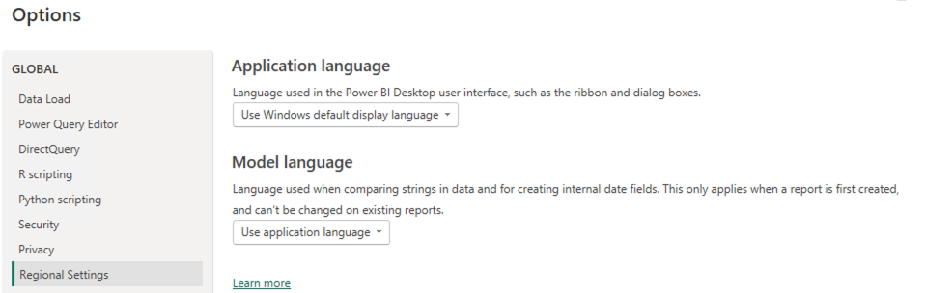
- Illegal Characters in Path
  - Issue: Unable to load the data file to the template and received the following error:
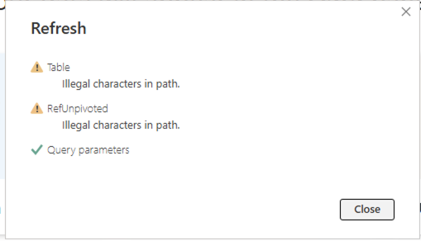
  - Solution: Remove the double quotation symbols at the beginning and the end of the file path.
  - Screenshot:
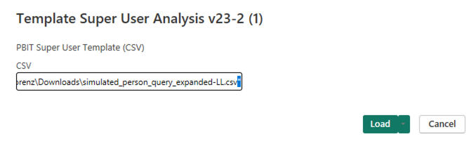
Other Power BI specific troubleshooting scenarios and best practices
- Troubleshoot Power BI specific issues
  - Troubleshoot refresh scenarios
  - Troubleshoot subscribing to reports and dashboards
- Power BI sign-in issues
- Forgot sign-in password
- Troubleshoot other sign-in issues

